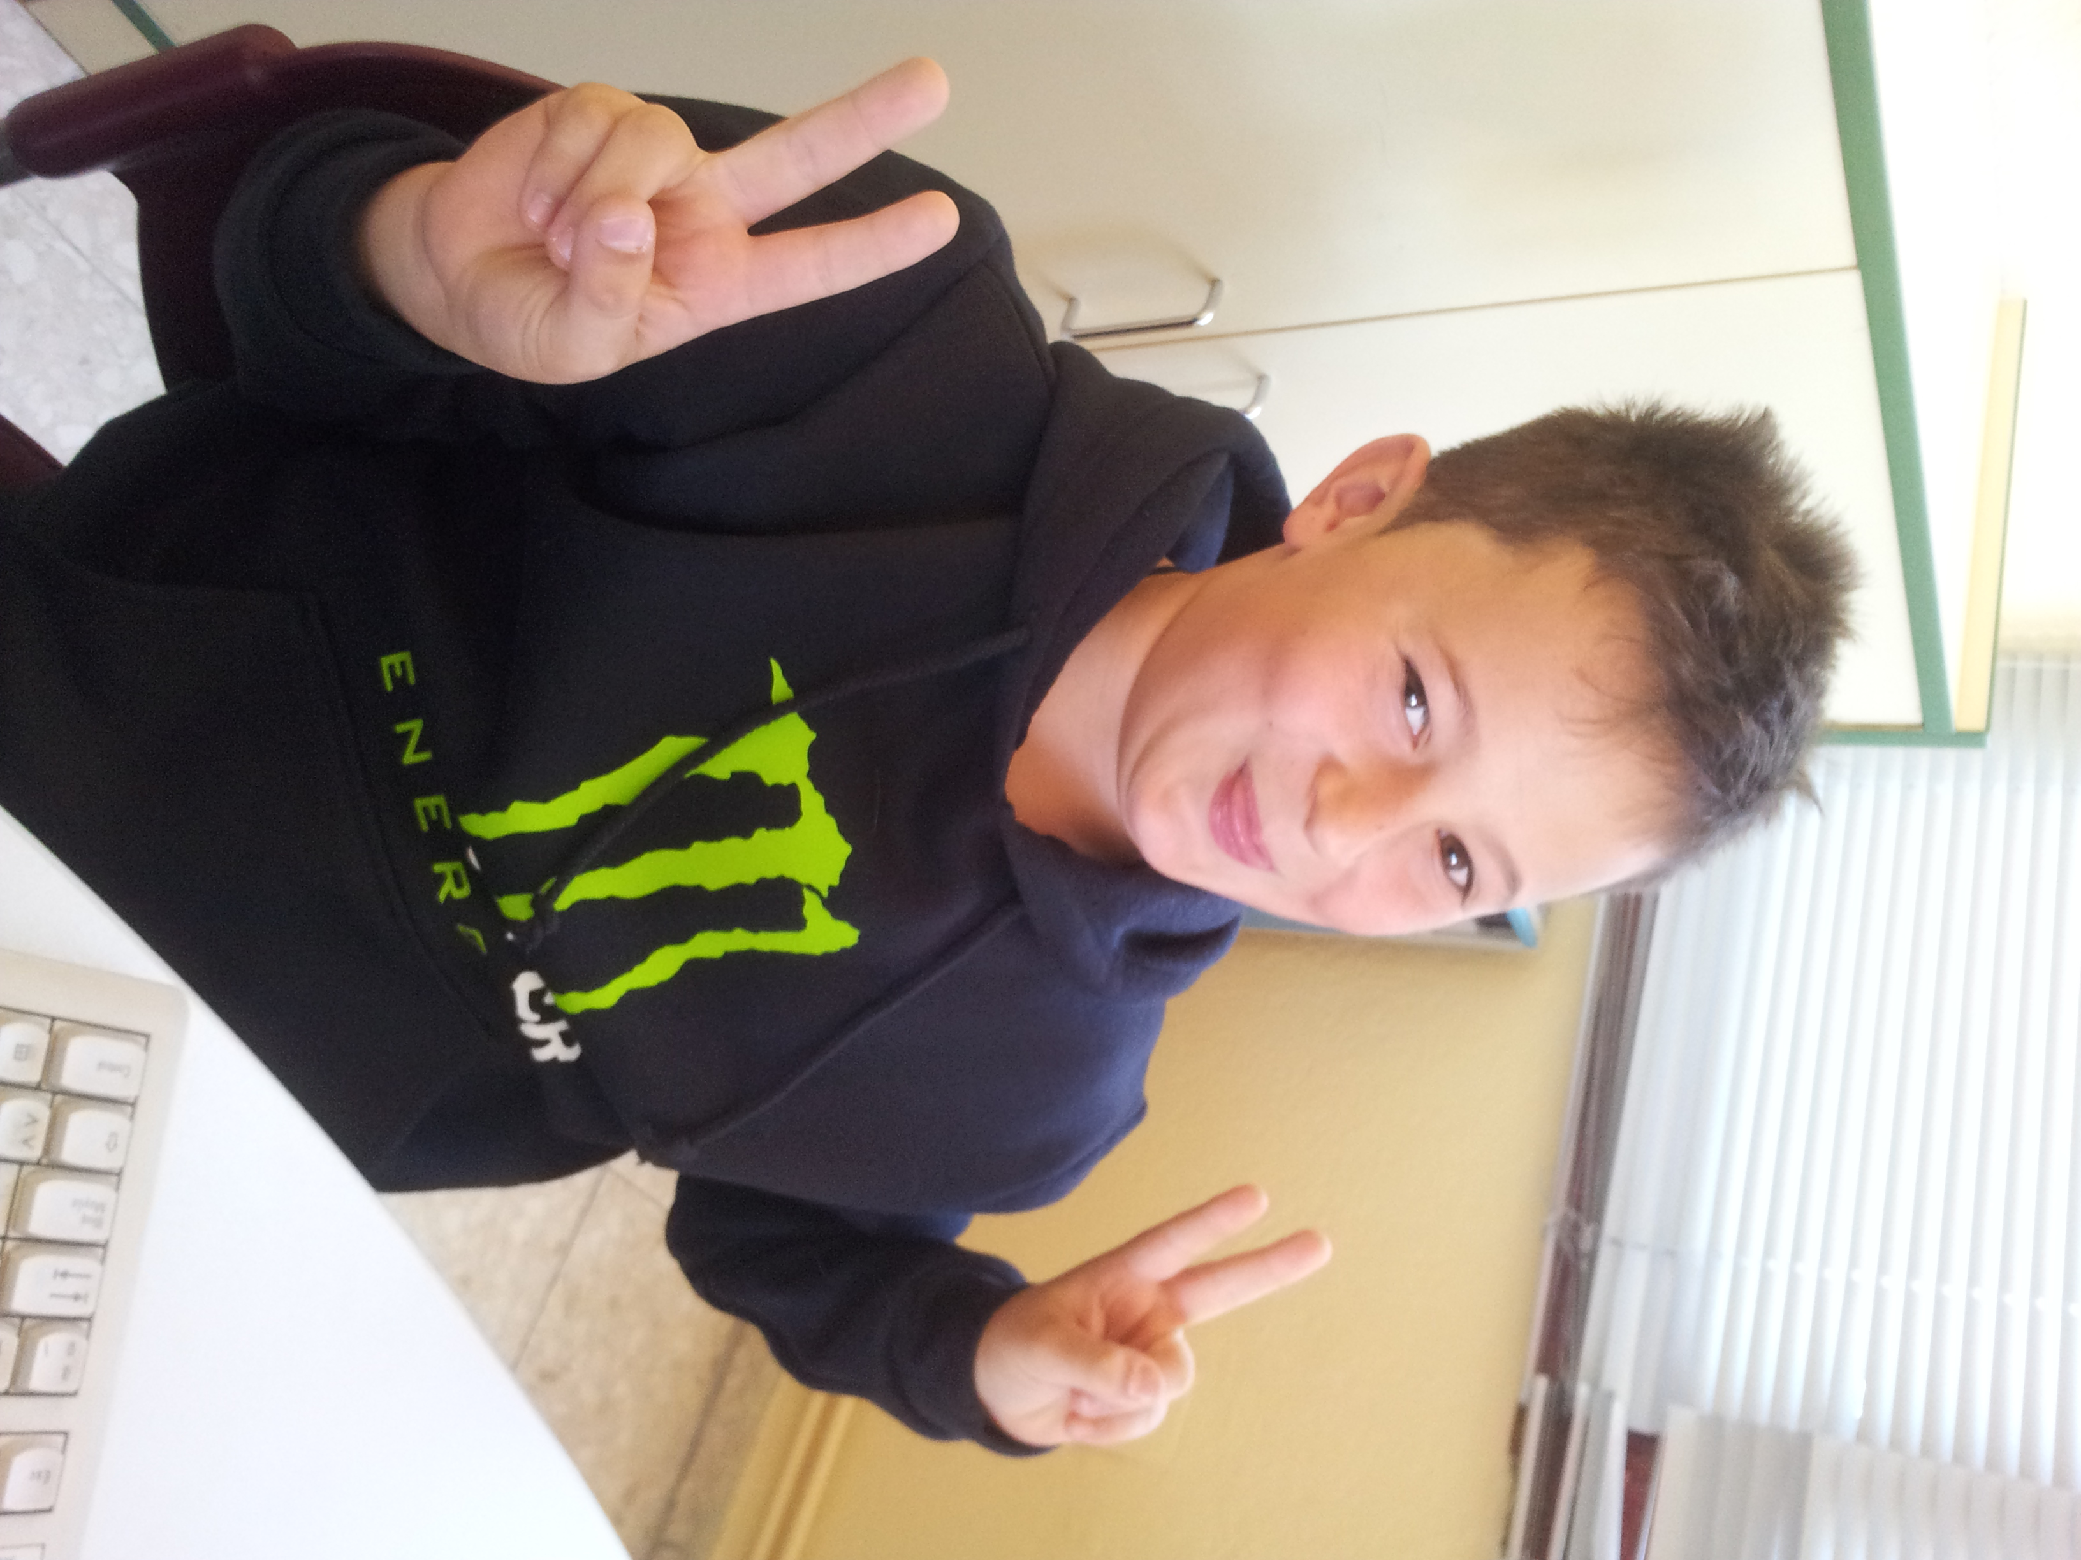
Hello

My name is Javier.
I´m 9 years old.
I´m from Spain.
I live in Socuellamos .
I go to school by car.
today is Friday.
My school ´s name is Gerardo Martinez.
There are twenty-four students in my classroom.
My english teacher is Carlos.
My best friend is Daniel.

